ORGANISATION

- The Essex League Cup ("the Competition") shall be controlled and administered by the Essex League Executive Committee ("the Committee").
- The decision of the Committee in each and every circumstance relating to the Match Rules and Playing Conditions and to matches played in the Competition shall be final and binding on all concerned.
- Essex League Clubs in the 1st XI Premier Division and 1st XI Divisions One and Two shall be eligible to participate in the Competition.
- A cricketer shall only be eligible to play for a Club in the Competition if he is registered to play for that same club in the Shepherd Neame Essex League and has been registered by and/or played for no other Saturday league club in the same season.
- No player may represent more than one club in the Competition in any one season.
- Regulations governing the eligibility of both Contracted players and Overseas and Overseas Exempt players are as described in the Generic Rules.
- The draw for all rounds of the Competition shall be made by and be under the control of the Committee.
- The club drawn at home shall be responsible for all match arrangements. Matches must be played by the appointed date set down by the Committee.
- The Committee shall be responsible for appointing ECB ACO qualified umpires for all matches in the Competition.
- Scorers: Each team shall provide their own competent, non-playing scorer in all matches. If a team fails to provide a scorer a player has to be nominated from the team to take up the duty for the entire duration of the match. They will then play the match with 10 players only.
- All matches shall be played with identical new balls nominated and supplied to the home club by the Committee to ensure complete uniformity. Two new balls, one for each innings, shall be used in each match. Both teams should arrive at each match with TWO League Cup balls, and the winners will retain their balls for the next round.
- In the event of no decision being reached in a match because of inclement weather, inability to rearrange a fixture before the deadline date, or for any other reason then in the last resort the decision shall be made by the toss of a coin between the two captains when both are present. In the event of the captains not being able to be present, the tossing of a coin shall be referred to the Committee. (N.B. If both captains wish to resolve the decision of the match by another means, e.g. bowling at stumps, then such a decision will be accepted by the Committee). It is also possible to rearrange such a fixture but this must be done within 14 days of the cancelled match.
- The captains shall agree before play begins what action shall be taken if a decision is not reached and shall confirm this action with the umpires.
Essex League generic rules also apply to this competition where relevant.

NOTIFICATION OF RESULTS

The result of each match must also be submitted to Play cricket in the normal way
MATCH RULES AND PLAYING CONDITIONS

The Laws of Cricket will apply with the following special regulations:

- Matches shall be of 45 overs a side and shall start at 12:00pm.

Where time is lost after the scheduled start due to inclement weather, then the number of overs shall be reduced as hereinafter provided in these Rules.

The latest finish time in rain affected games is 7:40pm. This time is known as the scheduled close of play as described below.

The latest start time for a 20 over per side match is4:50pm.

Matches will be played in white clothing using a red cricket ball.

2. There will be a tea interval of 30 minutes in between innings. In matches where time is lost for inclement weather, the tea interval may be taken (at the discretion of the umpires) during a rain delay, in order to save time subsequently – see 4.iii. In this instance the interval between the innings will be 10 minutes and 20 minutes will be saved from any time lost to the weather.

3. No bowler shall bowl more than 9 overs in a match, nor more than one fifth of the total number of overs in the innings except where that total is not divisible by 5.

If, for example, a match is reduced to 41 overs, one bowler may bowl 9 overs and 4 other bowlers shall bowl 8 each. (Note – in certain situations this may lead to a bowler having already exceeded his recalculated quota of overs following a rain interruption.).

In the event of a bowler breaking down and being unable to complete an over, the remaining balls will be bowled by another bowler who has not bowled the previous over and will not bowl the next over. Such part of over will count as a full over only in so far as each bowler’s limit is concerned.

4. Interruptions to play

- If due to inclement weather a match starts up to 30 minutes late, it shall remain a match of 45 overs. In the event that the match commences more than 30 minutes late, for any reason whatsoever, then one over shall be deducted from each innings for every 8 minutes or part thereof lost after the 30 minutes of ‘free’ time. No variations will be allowed to this rule and it is therefore essential for the captains and umpires to agree on the match clock before the start of play.

- 30 minutes of delays for inclement weather are allowed in total (including prior to the start and during either innings) before any overs are deducted (the “free” time).

- In matches where time is lost due to inclement weather the tea interval may be taken (at the discretion of the umpires) during a rain delay in order to save time subsequently. In this instance 20 minutes will be deducted from any lost time used to calculate future over reductions.

- When play is suspended during the first innings the object shall be to rearrange the number of overs so that both sides have the opportunity of batting the same number of overs (minimum 20 overs per side). One over shall be deducted from each innings for every 8 minutes or part thereof lost during the first innings.

- If owing to a delayed start to the second innings or a suspension of play during the second innings there is insufficient time for the side batting second to face the same number of overs as the side batting first, then the number of overs to be bowled will be those that could be bowled by the scheduled close of play assuming a rate of 4 minutes per over subject to a minimum of 20 overs. The number of overs to be faced by the team batting second will never be increased after an interruption.

- In the event of a suspension occurring in the middle of an over, the number of full overs to be bowled will be calculated and any balls remaining to be bowled in the over during which play was suspended will be added.

- Should the loss of time result in less than 20 overs being available to both teams the game shall be abandoned, regardless of the match situation when this point is reached.

- It is not possible to declare the innings or retire any remaining batsman out in the first innings, to enable a match to continue to a conclusion. This is not deemed to be within the Spirit of Cricket. Clubs have to accept that the weather will intervene unfavourably on occasions.

5. Restrictions on the placement of fielders

- Two semi-circles shall be drawn on the field of play.

- The semi-circles shall have as their centre the middle stump at either end of the pitch. The radius of each of the semi-circles shall be 30 yards (27.4 metres). The ends of each semi-circle shall be joined to the other by a straight line drawn on the field on the same side of the pitch.

- The field restriction area should be marked by painted white ‘dots’ at five-yard intervals, each ‘dot’ to be covered by a white plastic or rubber (but not metal) disc measuring seven inches in diameter.

- At the instant of delivery, there may not be more than five fielders on the leg side.

- At the instant of delivery:

  - Powerplay 1 - no more than two (2) fielders shall be permitted outside this fielding restriction area. In an innings of 45 overs, these are overs 1 to 9 inclusive.
  - Powerplay 2 - no more than four (4) fielders shall be permitted outside this fielding restriction area. In an innings of 45 overs, these are overs 10 to 36 inclusive
  - Powerplay 3 - no more than five (5) fielders shall be permitted outside this fielding restriction area. In an innings of 45 overs, these are overs 37 to 45 inclusive
  - In circumstances when the number of overs of the batting team is reduced, the number of overs within each phase of the innings shall be reduced in accordance with the table below. For the sake of clarity, it should be noted that the table shall apply to both the 1st and 2nd innings of the match.
  - If play is interrupted during an innings and the table below applies, the Powerplay takes immediate effect. For the avoidance of doubt this applies even if the interruption has occurred mid-over.

EXAMPLES

A 45 over innings is interrupted after 8.3 overs and reduced to 32 overs. The new phases are 7+19+6. Therefore the middle phase fielding restrictions take immediate effect when play resumes and last for a further 17.3 overs. The final phase begins after 26 overs have been bowled.

A 40 over innings is interrupted after 18.5 overs and reduced to 22 overs. The new phases are 5+13+4. When play resumes, the final phase fielding restrictions apply for the remaining 3.1 overs.

At the commencement of the middle and final phases of an innings, the umpire shall signal such commencement to the scorers by rotating his arm in a large circle.

- In the event of an infringement of any of the above fielding restrictions, the umpire at the striker’s end shall call and signal ‘No Ball’.

Innings duration | Powerplay 1 | Powerplay 2 | Powerplay 3
20 | 4 | 12 | 4
21 | 4 | 13 | 4
22 | 5 | 13 | 4
23 | 5 | 14 | 4
24 | 5 | 14 | 5
25 | 5 | 15 | 5
26 | 5 | 16 | 5
27 | 6 | 16 | 5
28 | 6 | 17 | 5
29 | 6 | 17 | 6
30 | 6 | 18 | 6
31 | 6 | 19 | 6
32 | 7 | 19 | 6
33 | 7 | 20 | 6
34 | 7 | 20 | 7
35 | 7 | 21 | 7
36 | 7 | 22 | 7
37 | 8 | 22 | 7
38 | 8 | 23 | 7
39 | 8 | 23 | 8
40 | 8 | 24 | 8
41 | 8 | 25 | 8
42 | 9 | 25 | 8
43 | 9 | 26 | 8
44 | 9 | 26 | 9
45 | 9 | 27 | 9

6. Slow play

- All sides are expected to be in position to bowl the first ball of the last over of their innings within 3 hours playing time.

- If the team fielding first fails to bowl the required number of overs by the scheduled time for the cessation of the first innings, the full quota of overs will be completed and the batting side will be credited with 6 runs for every whole over that has not been bowled. This will apply to both innings of the match; if the team fielding second fails to bowl the required number of overs by the scheduled time for the cessation of the innings, then the batting side will be credited with 6 runs for every whole over that has not been bowled. If the side batting second is credited with runs in this way and this consequently takes their score past that of the side batting first then the match shall be deemed to be won by the side batting second. All penalties in this regard will be imposed immediately the ball first becomes dead after the scheduled or re-scheduled cessation time for the innings.

- In reduced overs games the time required to bowl the overs will be adjusted such that the fielding side should complete their overs at a minimum rate of 15 overs per hour with the same penalties as above for failing to achieve this over rate. Umpires should make team captains aware of the newly calculated deadlines for completion of the innings in these reduced over games.

7. No balls

- The delivery following any no ball called shall be a free hit for whichever batsman is facing it.

- If the delivery for the free hit is not a legitimate delivery (any kind of no ball or a wide ball), then the next delivery will become a free hit for whichever batsman is facing it.

- For any free hit, the striker can be dismissed only under the circumstances that apply for a no ball.

- Field changes are only permitted for free hit deliveries if there is a change of striker. However, any fielder within 15 yards of the striker may retreat to a position on the same line no more than 15 yards from the striker.

- The umpires will signal a free hit by (after the normal No Ball signal) extending one arm straight upwards and moving it in a circular motion.

8. Wide Balls

- Umpires are instructed to apply a very strict and consistent interpretation in regard to this Law in order to prevent negative bowling wide of the wicket.

- Any offside delivery which in the opinion of the umpire does not give the batsman a reasonable opportunity to score shall be called a wide. As a guide to the umpires for the calling of off-side wide balls the pitch markings must be expanded to include lines 17 inches (43.18cm) inside either return crease at both ends of the pitch (see below).

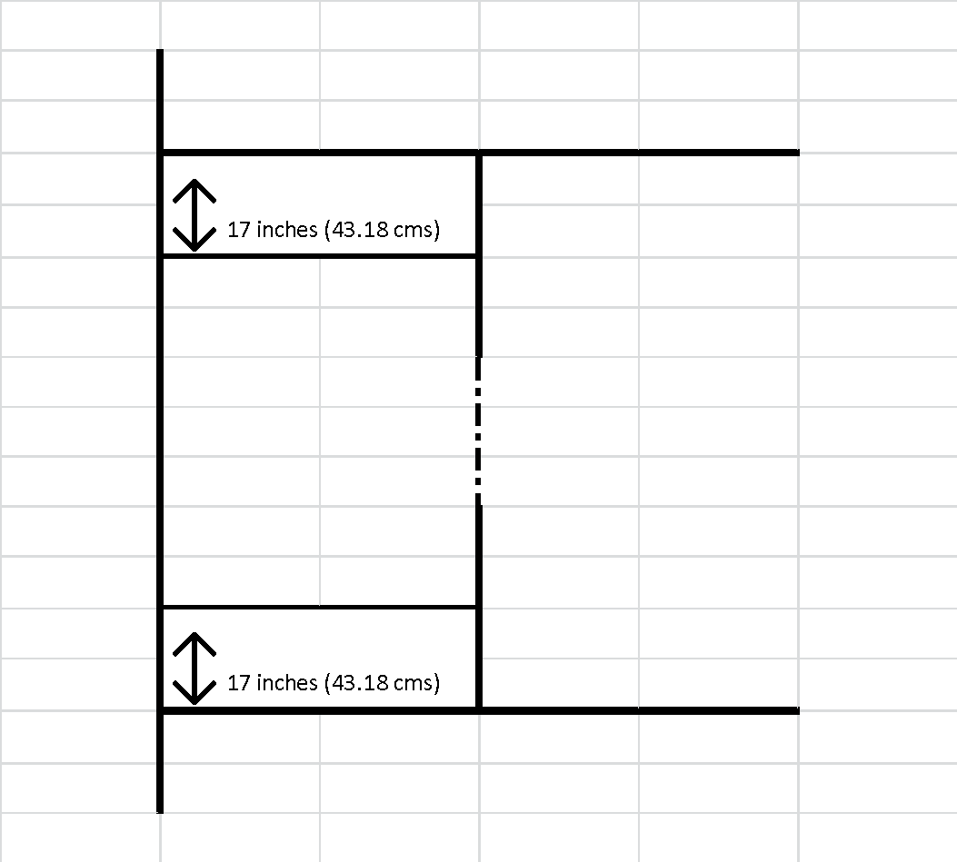

- A wide should be called for any ball that passes on the leg-side of the stumps. The only exception to this rule is if the batsman has moved to the leg-side and the ball passes between him and the stumps, then a wide is not called.

9. The result

- A result can only be achieved if both teams have had the opportunity of batting for at least 20 overs.

- Save as hereinafter provided the side which scores the most runs shall be the winners.

- If the scores are level in a match where the team batting second has had the opportunity of batting the same number of overs as the team batting first then the winner will be decided as follows:

  - The side losing the fewest wickets will be the winner.

  - If still equal, or if both sides were all out, the side with the higher score at the end of the completed penultimate over shall be the winner, and if still equal, at the end of the previous over, and so on until a winner can be decided.

- If due to suspension of play after the start of the match the number of overs in the innings of either team has to be revised to a lesser number than that originally allotted (minimum of 20 overs), then a revised target score should be set for the number of overs which the team batting second will have the opportunity of facing, this revised target score being calculated by the Duckworth Lewis Stern method.

- It is the responsibility of the Home Club to ensure that someone is present at each match who has access to the ECB Play Cricket Scorer App. This App is available on iOS or Android, it is free, it does not require a log-in nor a network to be fully functional. This App contains a Duckworth Lewis Stern calculator which should be used to calculate revised target scores or to determine the result in the case of an abandonment. The umpires will only be responsible for recalculating the overs and giving these details to the captains, scorer and Duckworth-Lewis-Stern Official. If the home club does not provide the above App in a rain interrupted game, then they will be deemed to have forfeited the match. The away club will be declared the winners and the offending club will take no points from the match

- The revised target score for the second innings will be determined by the Duckworth Lewis Stern Official and agreed by the captains, umpires and scorers.

- If after the restart of play it is discovered that the wrong Duckworth/Lewis target has been set then nevertheless the incorrect target shall stand.

- If the revised target score is exceeded then the team batting second will be the winner. If the revised target score is equalled then the scores are tied.
  - In this instance the winner will be decided as the side losing the fewest wickets. If this fails to separate the sides then a toss of the coin will be used.

- If a match is abandoned before it has been played to a conclusion and before the team batting second has received its allotted number of overs (providing that it has received not less than 20 overs) then the result shall be decided by the Duckworth Lewis Stern method.

